***E-Commerce Solutions Strategies***

**Introduction -**

This report will be covering the design of an E-Commerce solution based on a specified requirement or strategy. It will also examine the strategies employed and the impact of E-Commerce on business organisations.

If your business is an online store which is selling products or services, you might be interested in helpful advice on how to reach more customers using [E-commerce strategy](https://devrix.com/tutorial/cost-effective-lead-generation-tactics-e-commerce-business/).

A strategy is a summary of how your store is planning to achieve its goals and improve its position in the market.

There are different types of strategies depending on the goals. In this case, we will focus on how to reach more customers for your e-commerce business.

First of all, make sure your online store is:

* accessible from every type of device (PC, laptop, phone etc.).
* readable with clear design and information on it.

For this purpose, your E-commerce store needs to have a responsive web design and a mobile-friendly theme. Customers expect mobile-friendly sites. Businesses with a mobile-friendly website will make more sales over those which do not have one. Statistics since 2017 show that mobile device usage is either equal to or surpassing desktop usage.

Jan 2010Jan 2011Jan 2012Jan 2013Jan 2014Jan 2015Jan 2016Jan 2017Jan 2018Jan 20190%20%40%60%80%100%DesktopMobileTablet**StatCounter Global StatsComparison from Jan 2009 - Dec 2019**

Source: [StatCounter Global Stats – Platform Comparison Market Share](https://gs.statcounter.com/platform-market-share/desktop-mobile-tablet/worldwide/#monthly-200901-201912)

Web store home page, product pages, and product categories are the most visited places in an online store. How are they designed and how to be understood as well as possible? These questions may be answered by UX Design strategies.

What else can be done in order to make your online store more profitable?

Related: 6 Ways to Reinvent Your Ecommerce Website

## **1. Increase E-commerce Search Usability**

Does your e-commerce platform record or analyze what customers are searching for? If your online store system is able to track this, you are probably having effective navigation and search capability.

Organize your web store for these two main groups of potential customers:

* Visitors who know what they want to buy.
* Visitors who only want to browse.

Customers who know exactly what they are looking for want to find the right information as quickly as possible. Designing a high-performing search experience is a key feature for your users because if users can’t find what they are looking for, they will buy it from another store.

The second category is potential customers who just want to browse through the online store and compare items. They will use navigation menus and move into product categories and pages. You should organize the menu bar and categories in intuitive easy-to-use sections.

Does your website have well-designed search and navigation functions? They need to be user-oriented in order to be effective and help improve the overall experience customers are having on e-commerce websites.

To boost conversions in an e-commerce store you can improve the search usability in the following fields:

* design and behavior of the search field;
* search scope selection;
* how should the autocomplete be designed;
* results layout and features;
* filtering and sorting the search results on the results page.

## **2. Use High-Quality Photographs and Good Product Descriptions**



Include beautiful product images and photos to attract the attention of potential customers. Outside the brick and mortar world, customers can’t touch the product and are making their [buying decisions](https://www.communigator.co.uk/blog/consumer-decision-making-process/) entirely dependent on product imagery and feedback.

Showing good viewable thumbnails in the search results page will help users find the desired product in one click and get a better idea of what you are offering.

Don’t just describe the product – you can create a comprehensive list of features and benefits. Your target customers want to know everything about a potential purchase and how this product would help them and improve their everyday life.

### **Consider these tips when writing product descriptions:**

1. Create proper subheadings.
2. Use bullet points to attract attention.
3. Improve readability with larger font sizes.
4. Provide video and real photographs to your product.
5. Pay attention to white spaces through the content to make the copy more readable.

Website design and content creation should work together for optimal results. Make a copy part of your whole UX experience and enjoy higher conversion rates right away.

If you want to perfect your product descriptions you can check “[How to Write eCommerce Product Description: Best Practices](https://devrix.com/tutorial/how-to-write-ecommerce-product-description-best-practices/)” and try out some of the suggested practices.

## **3. Try Personalizing the Home Page**

Personalization is a technique that records what customers viewed or visited on their last session on your website and makes new buying suggestions on every following visit based on past experience in the store. This can be a personalization based on previous behavior such as previous purchases or based on real-time data such as a location or time.

*59% of online shoppers believe that it is easier to find more interesting products on personalized online retail stores”, invespcro.com, Online Shopping Personalization – Statistics and Trends*

Amazon is the pioneer of the user-centric shopping experience. Their homepage helps people easily find the right product in the personalized block in the first section when you log in under the “related to items you’ve viewed” tag.

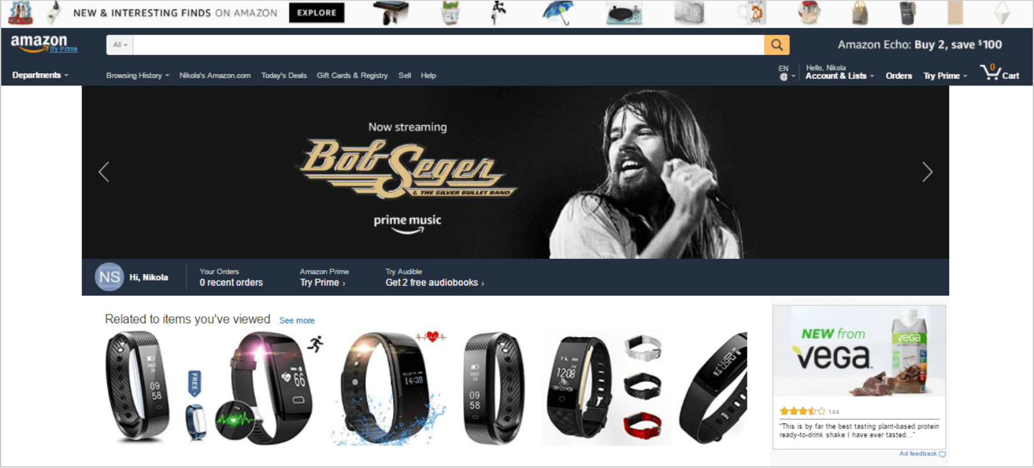

## **4. Focus on Consistent and Unique Content**

Why? Because content marketing is still one of the most effective marketing strategies you can apply today. The world of advertising is constantly changing, consumers are trying to avoid ads in many ways. With content strategy implemented the right way in your e-commerce business, you can provide more value to your customers.

To do this, you first need to understand your customers and how your product would help them and solve their problems. The main thing is to focus your content production around your customer’s problems and what value you can provide to them.

Don’t forget to first understand your target audience, what their interests are, their demographic data, etc. When done the next step is to make a plan for your posts. Publish relevant, valuable articles with good and easy-to-share options. Best tips for good-looking content is to include:

* Lists – They are more readable from paragraphs.
* Advice headlines with “How to” text relate to your reader’s problems.
* Topical posts – Which are relevant to something trendy and popular.

Do tests with headlines, measure how well different types of content work, which generates the most traffic to your online store, and which of them led to the most sales.

If your target audience are millennials we have great ideas on how you can attract them to your eCommerce website.

## **5. Optimize Shopping Cart Functionality**



To prevent customers from abandoning their shopping carts, you should be sure shopping cart functionality is perfect and easily navigable. The way to understand weaknesses is to do tests frequently. Test different options on a page to reduce shopping cart abandonment.

During the optimization process, you should pay attention to revenue not in conversions because this is the main business goal. Clear the checkout page and remove distractions and/or possible places to exit. This will prevent any confusion during the checkout process. Plenty of conversion studies have shown that the fewer clicks during checkout, the higher your conversion rate will be.

Here’s a little bonus for readers that own a WooCommerce shop – check Tyche Softwares’ Abandoned Cart Pro Plugin for minimizing cart abandonment rates.

## **6. Build Email Lists**

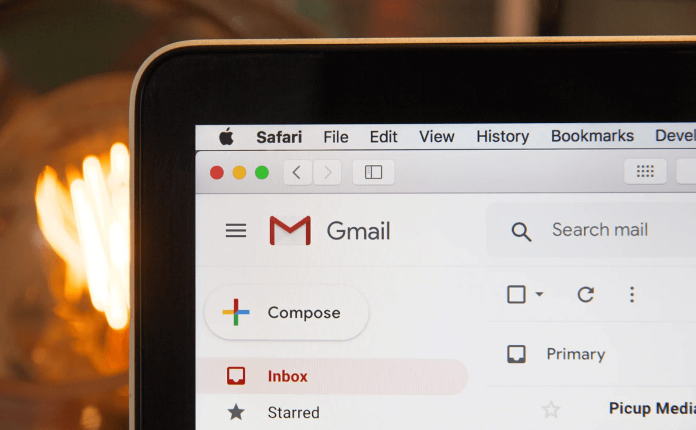

If your online business is not using email marketing as a communication channel, you are missing out on huge sales. Use sign-up forms, give something in exchange for an e-mail address like a discount code or even a small present. Make sure you win the customer’s trust and never send out emails without the user’s consent, otherwise you risk winding up in the SPAM folder and no one wants to ruin their brand like that.

Include sign-up fields at the end of your blog posts or buying guides. If the visitors enjoyed the content you provided them, they will be happy to keep in touch and get information about news, discounts, and promotions and will leave their email. Don’t forget to include an option, where the customer is able to join your mailing list as part of the checkout process.

An email list can never be “full” or ready, but as soon as your first customers start to opt-in for your newsletter, you can use their emails to:

* Promote new or upcoming products.
* Offer promotions or discounts.
* Send relevant and helpful blog posts.
* Ask for feedback.
* Create special newsletter-only campaigns and discount codes.

## **7. Improve Your Social Media Strategy**

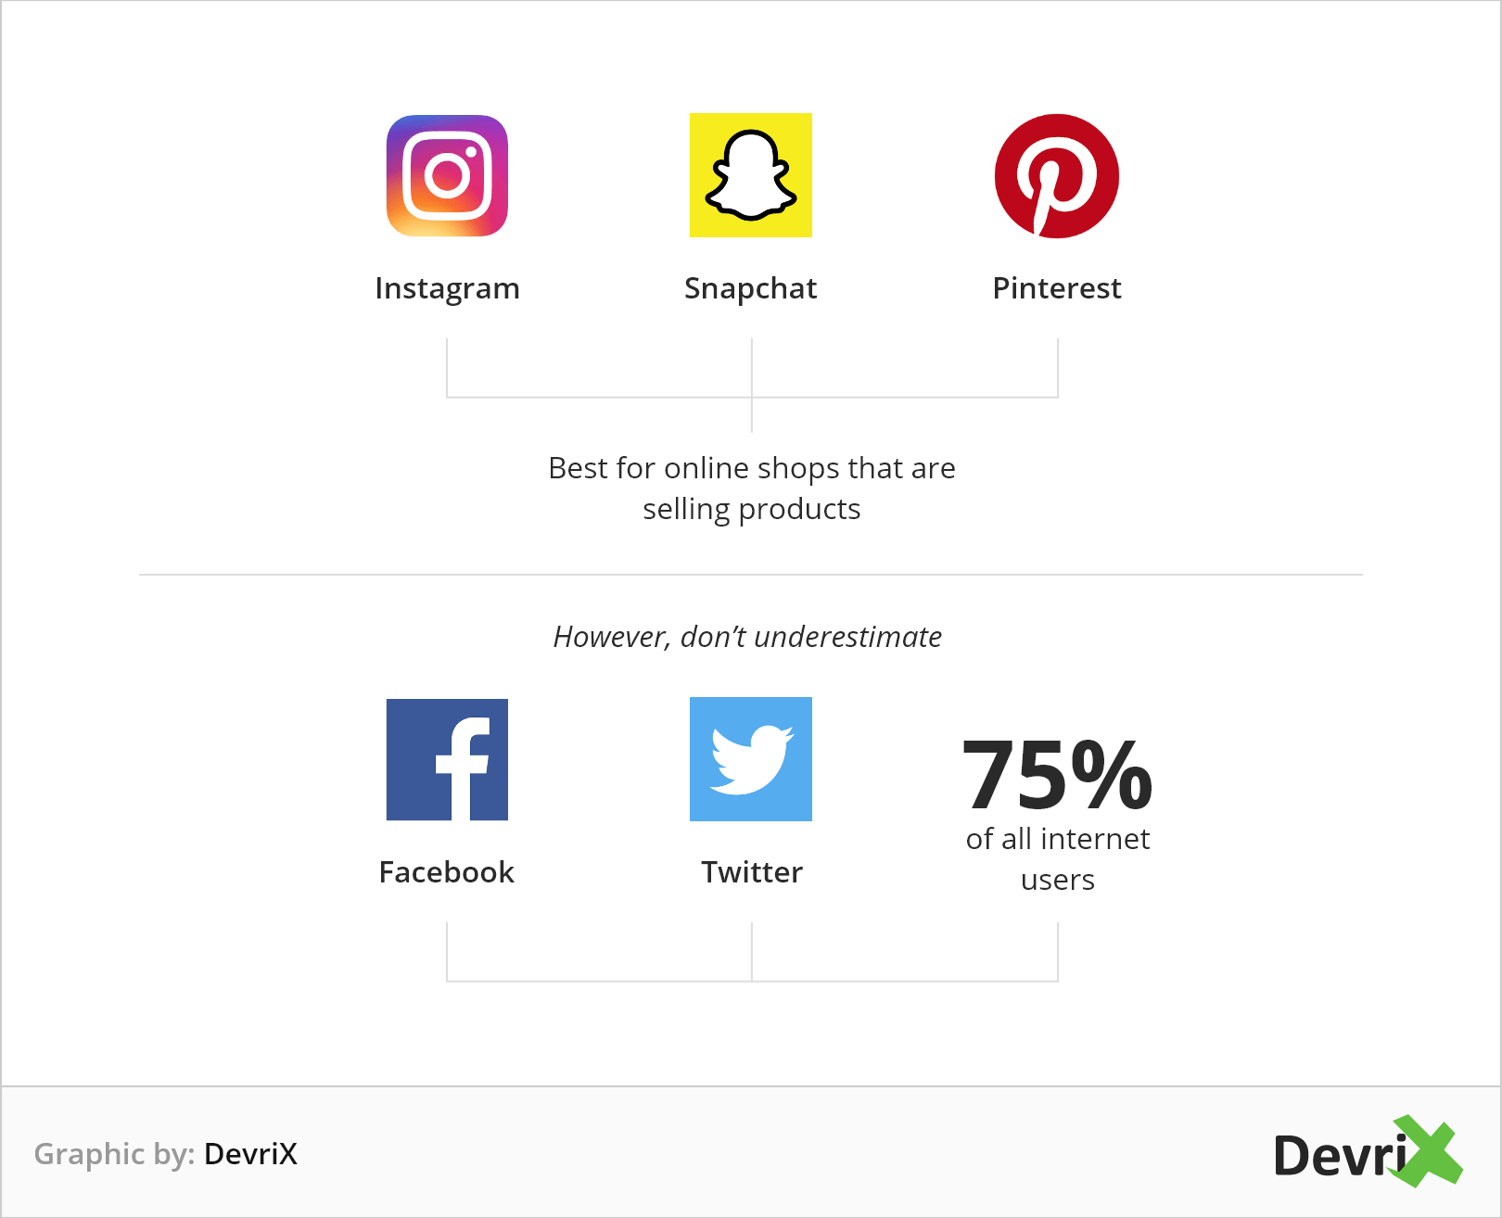

The social media strategy your marketing team prepares should be connected with your content strategy. The content creation from your e-commerce website should be published and shared on social media, as this guarantees you a larger audience and boosted visibility.

Visual social networks such as Instagram, Snapchat, and Pinterest, are usually best for online shops that are selling products, however, don’t underestimate Twitter and Facebook as more than 75% of all internet users are also there.

There is no one-size-fits-all solution, but here is a basic list of general guidelines you can check to see if your content follows in order to create the best customer experience for your clients:

* Post daily and consistently.
* Consider an automated tool to make sure your posts are on track.
* Always use images when posting, even on Twitter.
* Do not spam.
* Do not use social media for promotions only, engage with your customers.
* Use analytics to track your audience’s engagement.
* Test multiple social media marketing strategies before picking the right one for your business.

But how are we so sure social media marketing strategies can help your e-commerce business? Check some benefits that come with a well-tailored social media campaign:

* Gathering information about your customer’s online behavior allows for the creation of targeted ads.
* Building strong relationships with people – Daily communication with your customers helps any business to answer the buyer’s needs and provide a better user experience.
* Unique and high-quality posts on social media expand brand awareness and convert people to brand ambassadors.
* Better customer support – Over 67% of consumers use social media platforms for customer support. If your business answers are timely and really help your customers, they can get viral.
* Cost-efficiency – social media is the fastest and cheapest way of connecting with your customers.
* Higher conversion rates – In 2019, social networks influenced 74% of shoppers for their purchasing decisions

Implementing a social media strategy to your eCommerce store is obligatory. But after that you need to analyze how your social media channels are performing – your posts engagements, reach and campaign outcomes. In this tutorial, you can learn how to improve your social media campaign using data visualization.

## **8. Create Landing Pages**



With the development of personalized landing pages with a unique copy, your e-commerce online store increases the chance of attracting more customers who are willing to buy your products. Create specific landing pages for the different groups in your target audience. Outline your buyer personas and use analytics to determine the general demographic segments you are catering to.

### **How to build high-converting landing pages that drive sales, sign-ups or subscriptions?**

Here are some suggestions:

* A landing page should have only one single purpose and only one CTA (Call to Action) button. This doesn’t mean you can’t have multiple buttons, but they should all lead to the same conversion goal. Conversion rates decrease if the buyer’s attention isn’t focused well enough.
* Create clear user-friendly designs for all of your landing pages. The only clickable elements should guide the visitor to the desired goal. It is a good idea to hide the navigation bar at the top, social media icons or elements that can distract the visitors.

*The one thing you want your visitor to do should be the only thing they can do – Unbounce.*

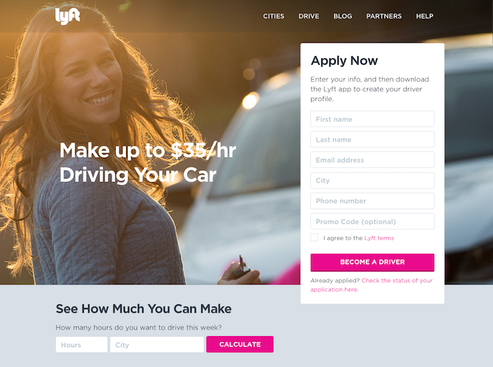

For further inspiration, you can check out this tutorial where you will learn [6 great tips on how to write a landing page copy that converts](https://devrix.com/tutorial/6-tips-to-write-landing-page-copy-that-converts/).

## **9. Build Advertising Strategies**

E-commerce shop advertisements help to improve your online visibility and boost sales. Before starting an ad campaign, you should answer three questions: How many visitors does your business’ website need for a successful conversion? How much is the budget you can safely allocate and for what period of time? What is the best advertisement outlet for your products? These answers will help you to make some calculations and predictions and will narrow your advertisement options.

Most people choose to start with Facebook Ads or Google Adwords – The most popular and user-friendly platforms for advertising.

Whatever you choose, the most important part is to analyze and track the traffic to your website. Google Analytics, for example, is showing where are visitors coming from, and what are they doing on your website.

Retargeting methods to reach visitors and potential customers is also a smart move to increase ads effect. Facebook pixel is a tool that can keep a record of all the FB visitors on your website and help create targeted campaigns.

Then you can set-up preferences based on where your visitors spent their time on site – product page, blog, testimonials etc. Collecting information takes time and patience, but expanding your audience allows for a detailed analysis that gives better results.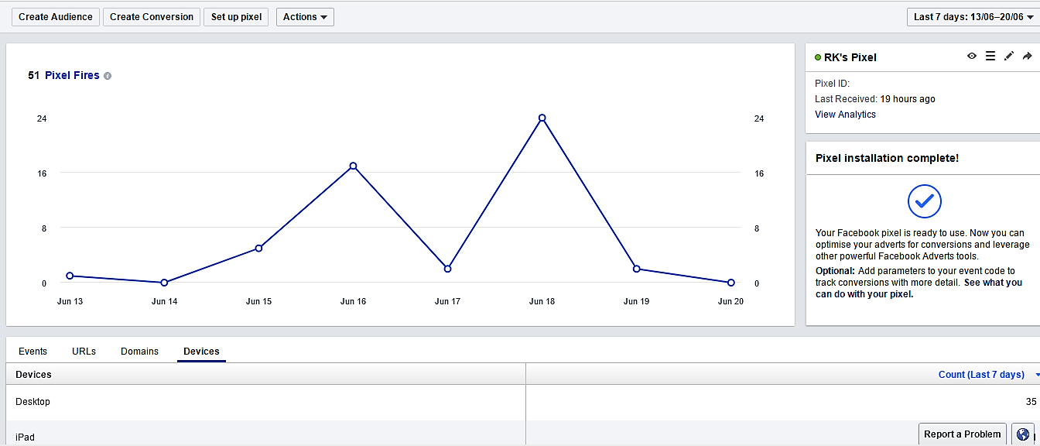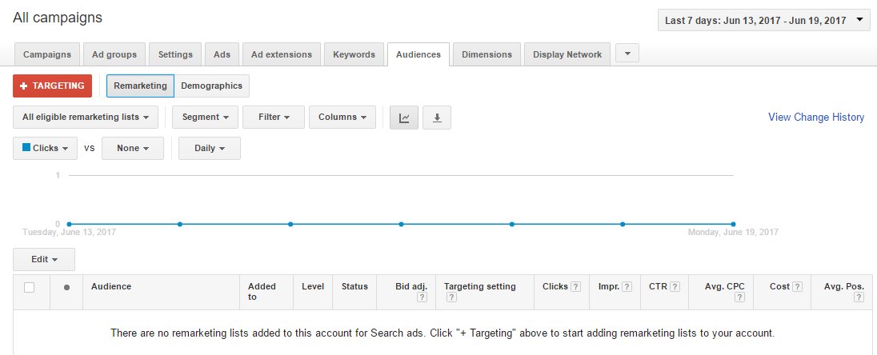

## **10. Implement User-Generated Content**

The UGC (User Generated Content) idea is simple: Consumers post content (video clips, pictures, testimonials, reviews, and blogs) that is publicly available online through social media and other sites, regarding your store, brand or product. Generated organic content can be either a positive or negative experience with an online store or products. UGS can help you gain more leads to your e-commerce website, because

*Shoppers that interact with CGC are 97% more likely to convert with a retailer than customers who do not. Brands see a 78% lift in conversion rates when customers interact with CGC.*

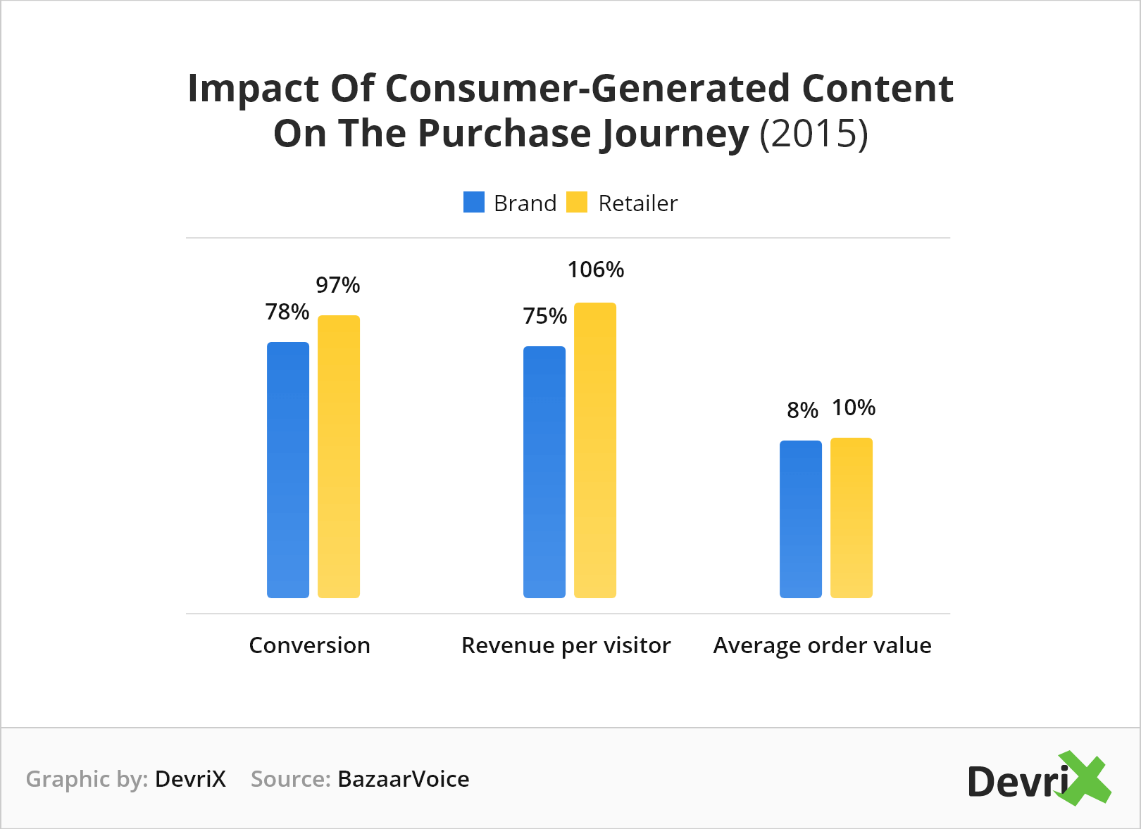

### **How can consumers generate content for you?**

Here are some helpful ideas:

* Organize product contests on social media and encourage people to share how they are using your products; you can also enable voting rules.
* Ask customers how they think can make your product better.
* Use campaigns on Instagram with branded company hashtags to encourage customers who love your brand to post images and tag you.
* Try reaching new potential customers and check if there are viral social channels you are not already using.
* Use real-time interactions with Facebook Live videos, Twitter’s Periscope app, Youtube Live or other Live stream platforms and services.



## **Conclusion**

The digital strategies for [e-commerce stores](https://devrix.com/tutorial/wordpress-ecommerce-10-things-need-know/) that we listed are a small part of the opportunities your business can use to reach more customers online. Every point of this article shows ideas which can be developed into working sales.

Analyze your webpage, test some of the patterns we have outlined, and give us feedback on what works well for your business and what you need to improve. You can always [contact](https://devrix.com/contact/) DevriX and schedule a call with one of our [marketing specialists](https://devrix.com/inbound-marketing/) for in-depth analysis and any kind of marketing tips and tricks.